Day 3 lab Answers

Task 1
Prevent Table Extension:
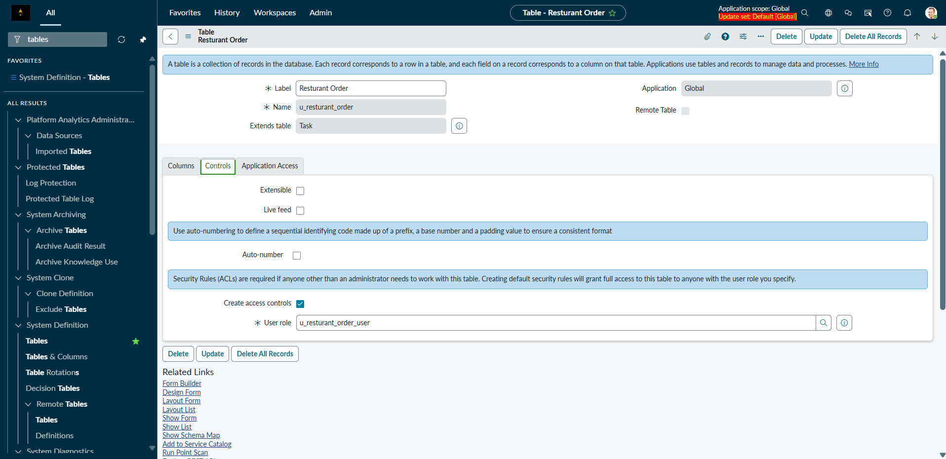

Task 2
Create a child Table:
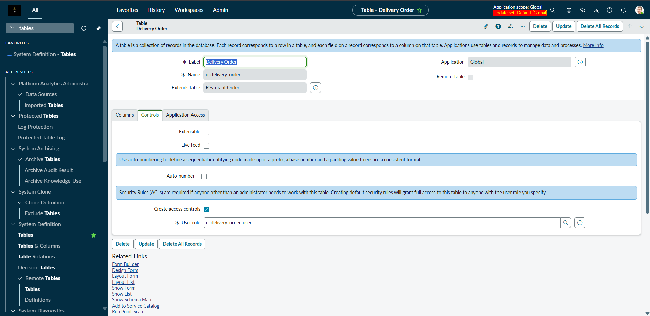

Task 3
Create Fields:
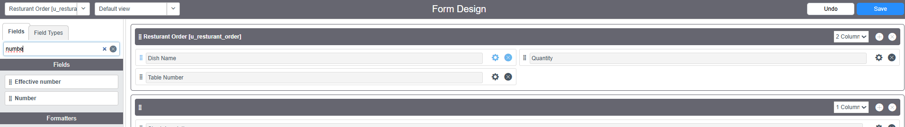
Created 3 fields named Dish Name, Table number and quantity and added them to a form builder

Task 4
Reference Name:
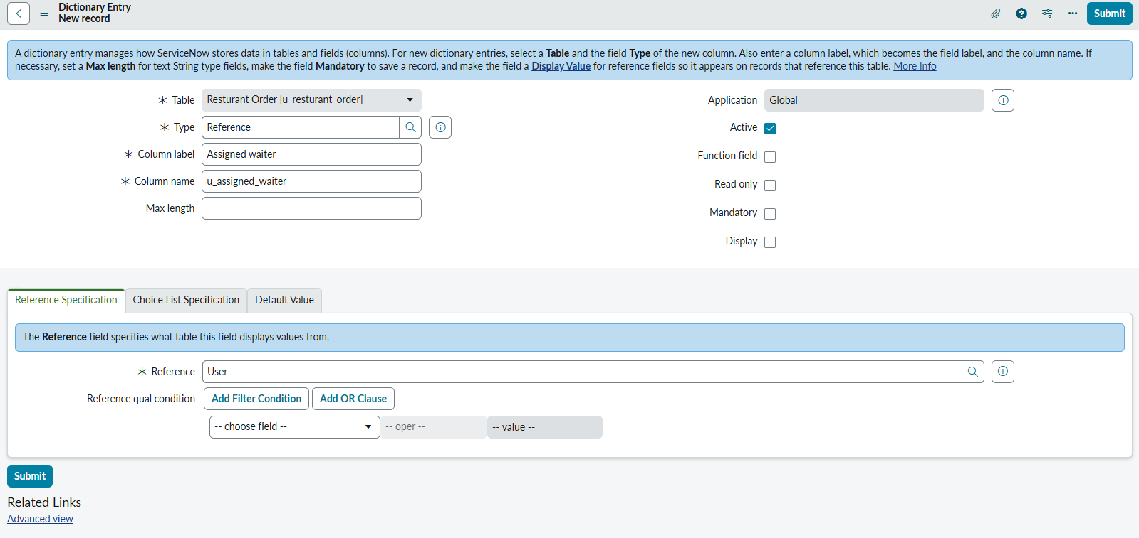

Task 5
Dictionary Configuration:
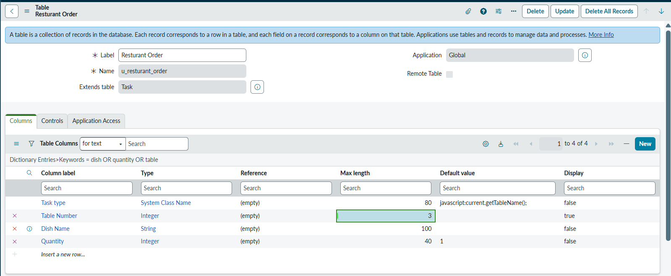

Task 6
Dictionary Override:
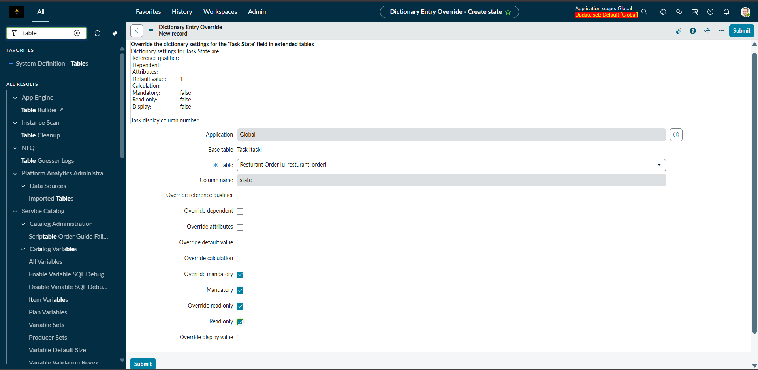

Task 7
Validation:
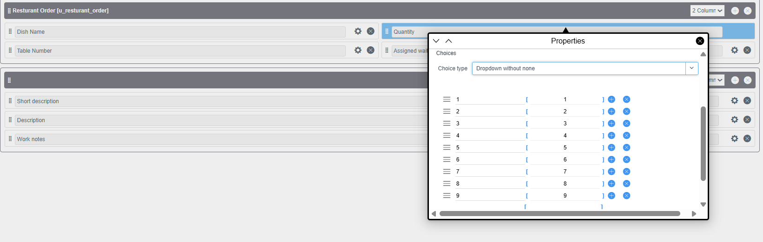

Task 8
Default Form Design:
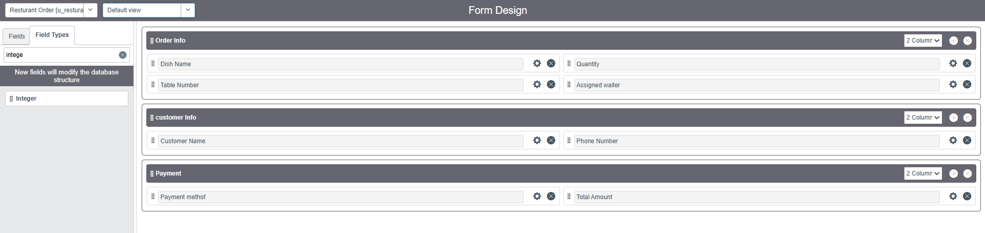

Task 9
Chef View:
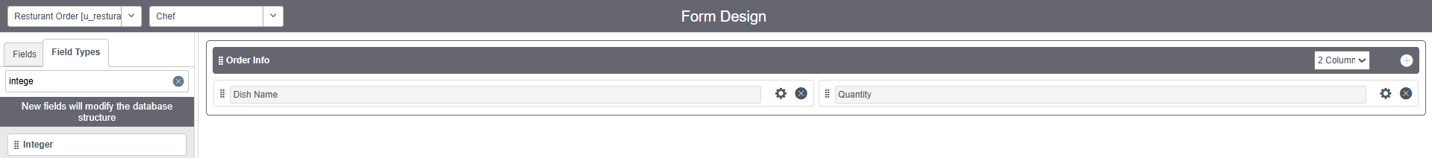
Manager View:
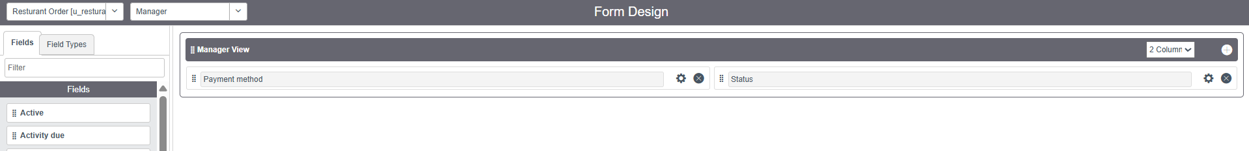

Task 10
Custom List View:
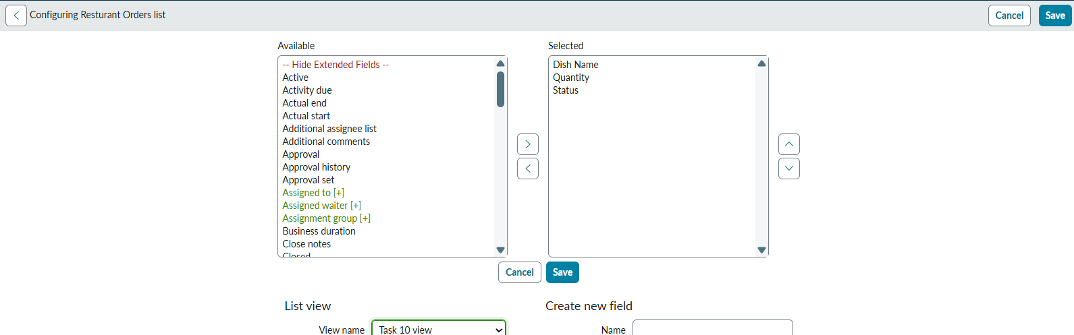

Task 11
Filter:
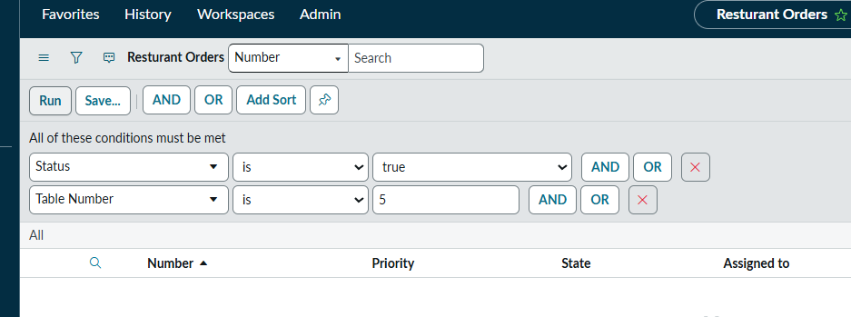

Task 12
Number Maintenance:
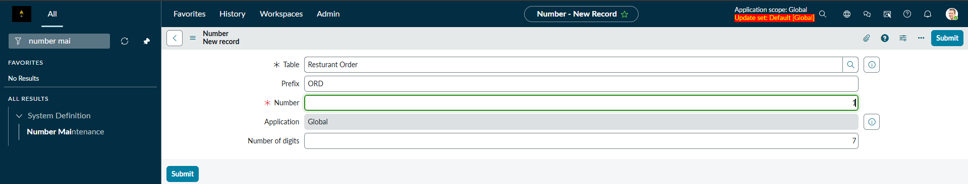

Task 14
Schema Map:
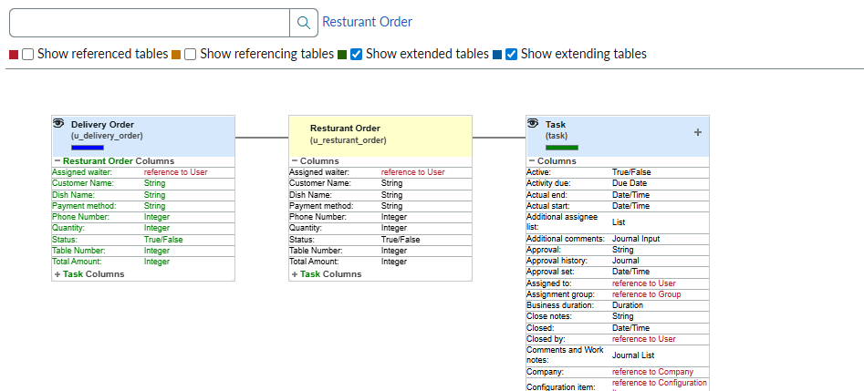

Task 15
Application Creation and its module:
